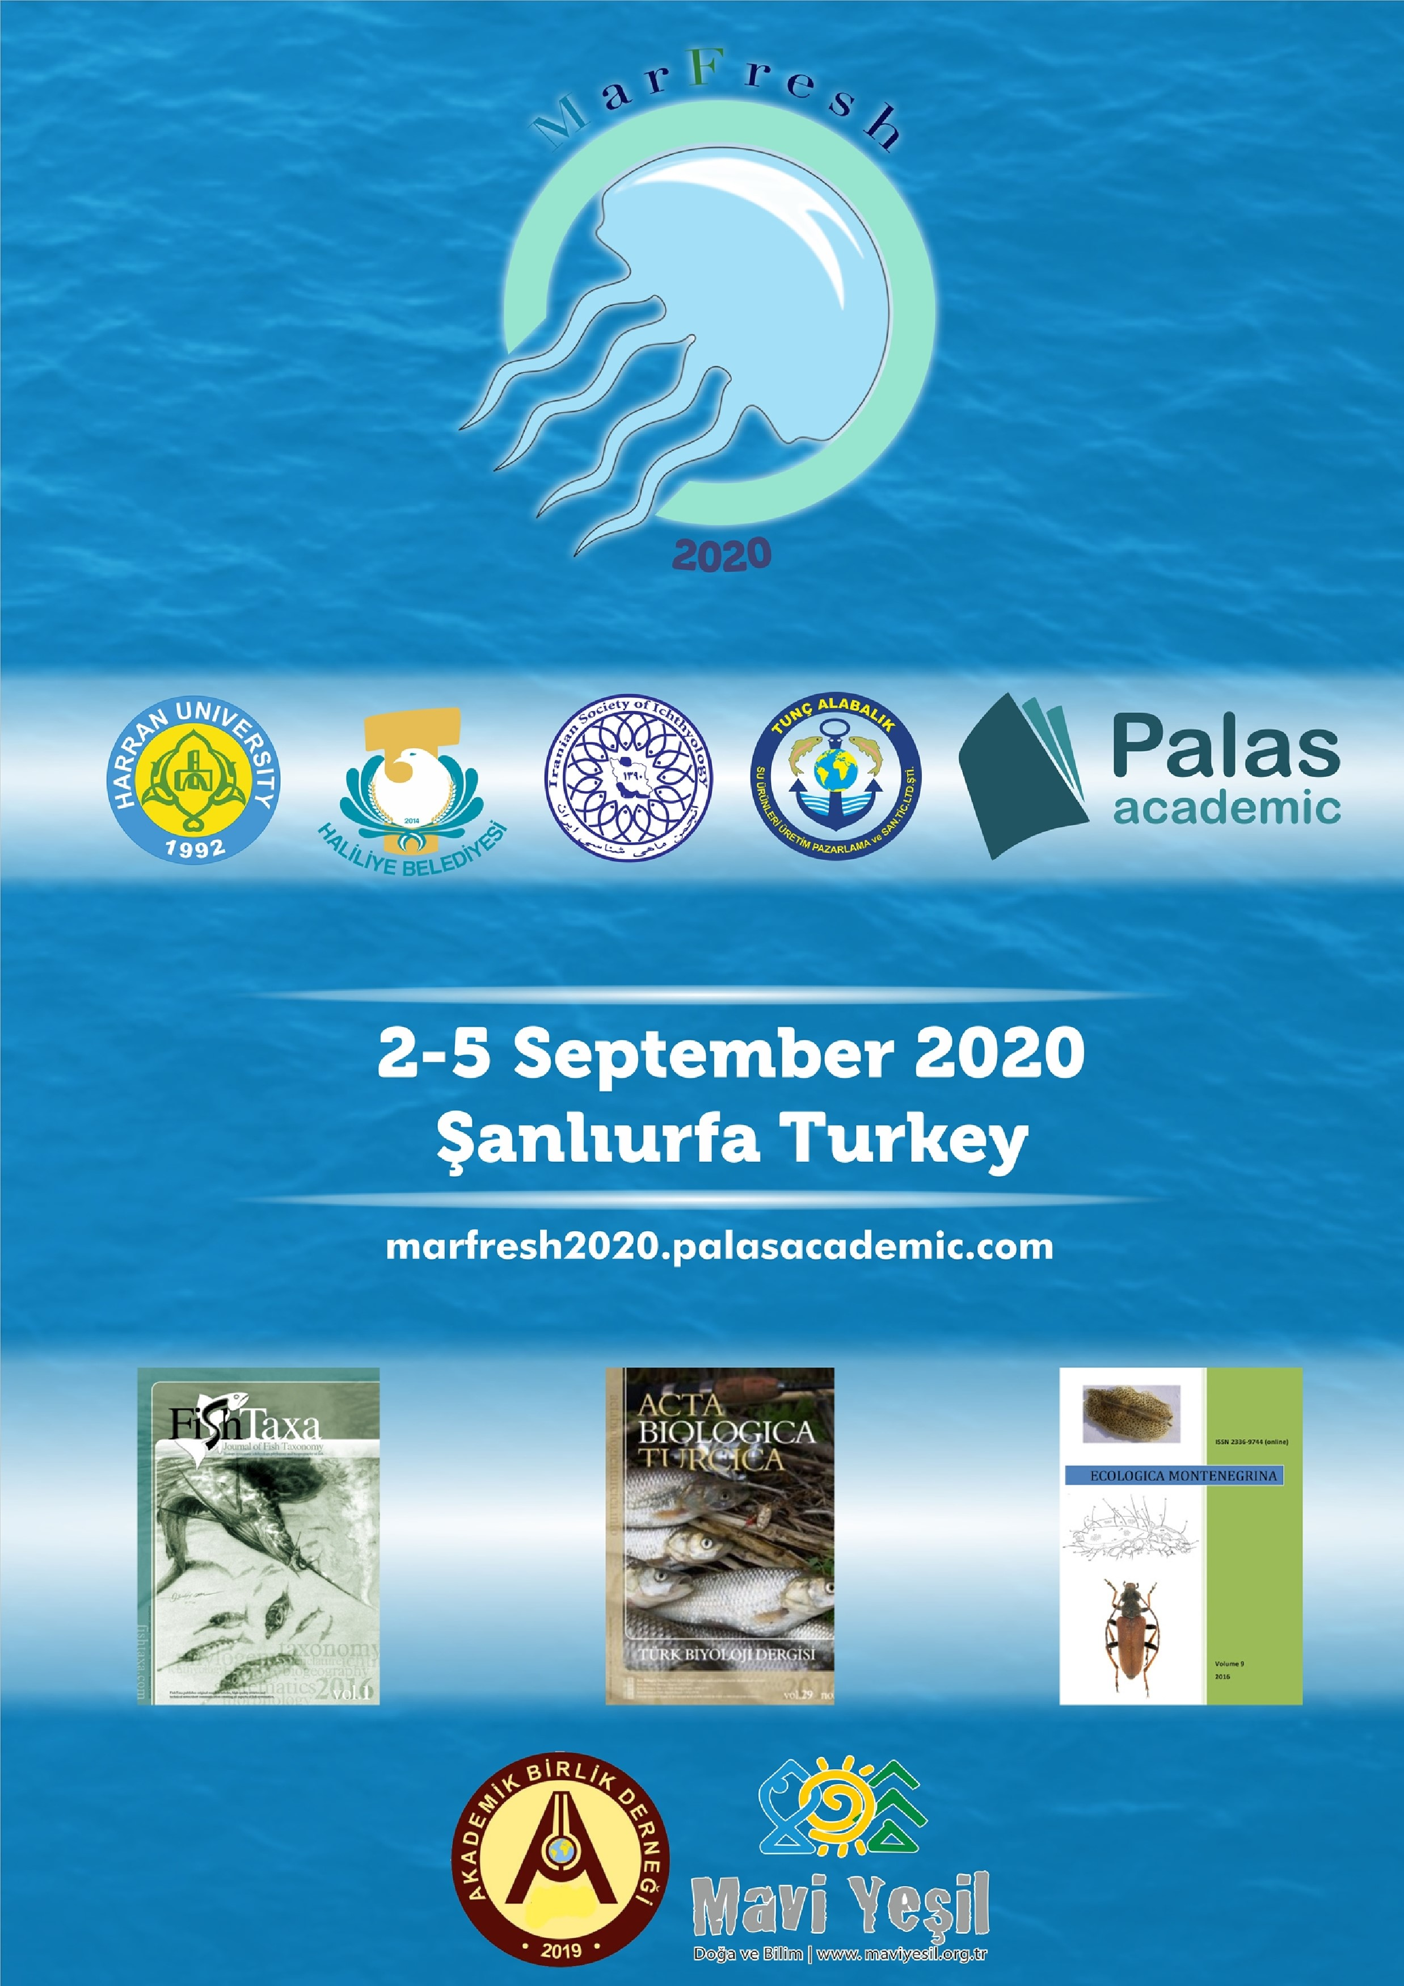
Evrak Tarih ve Sayısı: 16/07/2020-E.26764
2nd INTERNATIONAL MARINE & FRESHWATER SCIENCES SYMPOSIUM (MARFRESH 2020)
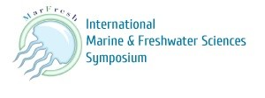
Co-Organizing İnternational İnstitutions MARFRESH 2020
❒ Harran University, Turkey
❒ Haliliye Municipality, Şanlıurfa/Turkey
❒ Iranian Society of Ichthyolgy, Iran
❒ Tunç Alabalık Şanlıurfa/Turkey
❒ Palas Academic, İskenderun/Turkey
❒ Acta Biologica Turcica
❒ FishTaxa, Journal of Fish Taxonomy and Systematics
❒ Ecologica Montenegrina
❒ Akademik Birlik Association
❒ Mavi Yeşil Doğa ve Bilim Association
More information on the website: https://marfresh2020.palasacademic.com/

2nd INTERNATIONAL MARINE & FRESHWATER SCIENCES SYMPOSIUM (MARFRESH2020)
September 02-05, 2020 ─ Şanlıurfa-Turkey
Dear Colleagues,

It is a great pleasure to invite you to the "2nd International Marine & Freshwater Sciences Symposium (Marfresh2020)", which will be held on 02-05 September 2020 in Şanlıurfa- Turkey, with the academic contributions of Harran University, Iranian Society of Ichthyology, Palas Academic and, contributions of Haliliye Municipality and Tunç Alabalık. We would be highly delighted with your participation. We would also be thankful if you could inform your colleagues about the symposium and encourage them for the participation.
Please note that an author can submit and present maximum 2 papers for the Symposium. There is no extra cost for second paper by same author. All contributions will be reviewed by the Scientific Committee and they reserve the right to decide form of presentation (oral/poster) in case of scope of the presentation or timing.
Deadline for the submission of the presentation is 1 August 2020. Articles of accepted presentations will be published free of charge in an e-proceedings of symposium proceedings or in Acta Biologica Turcica, FishTaxa and Ecologica Montenegrina (charge a fee) a journal supporting the symposium, according to the choose of the author(s). Also, Registration for the symposium is obligatory. Detailed information can be obtained through the web site of the symposium; https://marfresh2020.palasacademic.com/
Marfresh2020 symposium online registration includes the following digital materials and services:
e-certificates [for Authors: Certificate of Attendance and Presentation; for Listeners: Certificate of Attendance; for Chairs: Certificate of Attendance]
e-program e-book e-name badge receipt e-presentation
As the organizing committee, we would be honoured and very pleased to see all who are interested in Marine & Freshwater sciences from related institutes, universities, ministries and nongovernmental organizations.
Thank you for your interest in advance.
Kind Regards,
Dr. Muhammed Yaşar DÖRTBUDAK
Symposium Topics
Biodiversity, Conservation & Environmental Protection in Aquatic Resources
Integrated Management of Coastal Zone – Transitional Water Ecosystems & River Basins
3E (Endemic, Exotic & Endangered) Species
Aquaculture
Fish diseases
Genetics & Population Genomics: from Genes to Ecosystem
Fisheries, Environmental Impacts, Monitoring & Management
Processing, Economics & Marketing of Fisheries Products
Climate Changes in Aquatic Ecosystems
Sea Level Rise Water Acidification & Hypoxia
Oceanography & Water Pollution
Marine/Inlandwater Biology & Ecology
Biogeochemical Cycles in Aquatic Ecosystems
Marine Protected areas
Environmental Education & Awareness
Waste Water Management
Ports and Maritime Transportation
Sea Pollution and Prevention
Petroleum and Energy
Anthropological Studies
Effects of Agricultural Activities
Tourism and Gastronomy
Official Symposium language:
The official Symposium language will be English.
Symposium venue:
Symposium will be held in Harran University Osmanbey Campus Conference Hall
Şanlıurfa/Turkey.
IMPORTANT DATES
Conference Dates | 02 - 05 September 2020
Deadline for Abstract / Full Paper Submission | 10 August 2020
Notification of Acceptance | Within 20 days after the submission
The Start of Payment of Conference Fees | Upon receiving acceptance letter
Deadline for Regular Registration | 10 August 2020
Scientific Schedule of the Symposium | 20 August 2020
Deadline for payments | 20 August 2020
Publication of the symposium book | October 2020

REGISTRATION FEE
Registration Fee | Participannts | Listeners/Stusdents/ Grup
20 August 2020 | 75 Euro / 400 Turkish Lira | 50 Euro / 300 Turkish Lira
The Göbektitepe Tour:
On Friyday 4 September 2020 there will be organized a Göbeklitepe Tour (4 hours; free transportation).
NOTE: All refund requests must be received in writing before August 20, 2020. There will be a 40 Euro service charge per person for all refunds. There will be no refunds after September 01, 2020.

NOTE: The certificates of attendance and presentation will be only issued for registered presenters who paid the conference fee.
VAT is included in above fees.
Conference Registration Fee includes (for Physical presentation):
- Access to all Sessions
- Coffee break during the conference
- Conference Program Book
- Conference Abstract Book • Name Tag
- Certificate of Participation
- Conference Bag
- Lunch during the conference
- Handbook & Conference Kit

More information on the website: https://marfresh2020.palasacademic.com/

