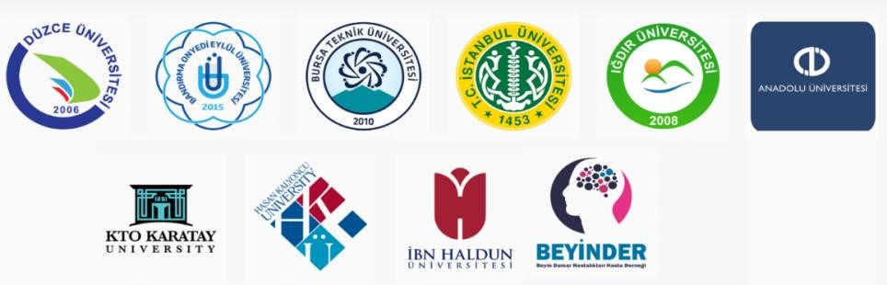

** Paper presentations will be live broadcast. Conference Webpage
Call for Papers
Online International Conference of Covid-19 (CONCOVID)
June 12-13-14, 2020
SKYPE Participation
Abstract Submission Deadline: June 1, 2020
Full Text Submission Deadline: July 10, 2020 (For CONCOVID Proceeding Book)
Registration Deadline: June 5, 2020

Distinguished Scholars,

We are honoured to invite you to the world’s first online INTERNATIONAL CONFERENCE OF
COVID-19 (CONCOVID, www.concovid.org) which will be organised on June 12-13-14, 2020 in Istanbul/TURKIYE. As an interdisciplinary conference, CONCOVID provides researchers with the opportunity to present share and discuss improvements and alternative solutions to the global pandemic Covid-19. In this context, we are welcome research papers from different disciplines such as medicine, education, economy, marketing, international relations, and social affairs.
- Presentations will be held over Skype presentation.
- The evaluation process for the acceptance of the papers will be completed within 3 days.
- The language of the CONCOVID Conference will be Turkish and English  It is optional to present full text paper.

Keynote Speakers*
⎈ | Prof. Dr. Gary Campbell, MIT, USA
⎈ | Prof. Dr. Obiyathulla Ismath Bacha, INCEIF, Malaysia
⎈ | Prof. Dr. Muhammad Shahbaz, Beijing Institute of Technology, China
⎈ | Prof. Dr. Tolga Omay, Atılım University, Turkey
⎈ | Dr. Stefano Siviero, Bank of Italy, Italy
⎈ | Dr. Kazi Sohag, Ural Federal University

Publication Opportunities
All of the papers presented at CONCOVID conference will be published in CONCOVID Abstract Book and CONCOVID Proceeding Book (Both have ISBN numbers). The selected papers will have opportunity to be published after blind reviewing in the Regular/Special Issues of the prestigious SSCI, SCOPUS and other indexed Journals shown below:
⎈ | Frontiers, Special Issue: “Coronavirus Disease (Covid-19): The Impact on Psychology of  Sustainability, Sustainable Development, and Global Economy” (SSCI, Q1) (No Submission Fee for CONCOVID Participants)
⎈ | Resources Policy, Regular Issue (SSCI, Q1)
⎈ | World Review of Science, Technology and Sustainable Development (WRSTSD) Special Issue Theme: “"The Global Economy, The Tourism Sector and Sustainable Development" https://www.inderscience.com/info/ingeneral/cfp.php?id=5196 (SCOPUS)
⎈ | SOSBİLDER: Iğdır University Journal of Social Sciences – Special Issue: COVID-19 with  Economic, Social, and Political Dimensions) (ULAKBİM, DOAJ, EBSCO, DRJI, ASOS,  INDEX COPERNICUS, ISAM)
⎈ | JOEEP:Journal of Emerging Economies and Policy (SIS,IIJIF,CIF)
⎈ | The Extended Abstract/manuscript (MS-WORD, PDF) should be submitted to
info@concovid.org

