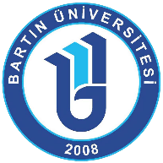

Student Mobility for Studies
Monthly Report
(to be filled by Erasmus+ Outgoing Student from Bartın University)

Participant’s Department at Bartın University :
Departmental Coordinator at Bartın University :
Host Institution (University and Code) :
Report Term : 2018-2019 / ……………………. (Month)

Please write at least 150 words of your report in which you mention the activities (academic & social) that you have done at the host institution in the last month.
This report will be sent to the departmental coordinator and Erasmus Office e-mail account (ulik@bartin.edu.tr) in the first week of the month including the information about the previous month activities.
Also, you will need to print the reports out with your signature so as to be submitted to Erasmus Office.

Student Name/Surname: Signature: Date:

